EVENT ACCOMADATION RECOMMENDATIONS
Below are some recommendations for accommodation for the STEM On Track Test Day and National Finals.
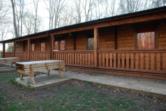
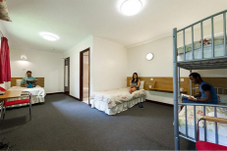
KINGS PARK CONFERENCE CENTRE
🚘 25 mins
📍Kings Park Rd, Northampton, NN3 6LL
📞 01604 493111
📩 enquiries@kingspark.org.uk
🌐 conference.naycacuk.co.uk
OVERSTONE SCOUTS ACCOMMODATION
🚘 30 mins
📍Billing Lane, Overstone, NN6 0AF
📩bookings@northamptonscouts. org.uk
🌐overstonescoutcampsite.org.uk

NATIONAL BADMINGTON CENTRE
🚘 40 mins
📍Bradwell Road Loughton Lodge MK8 9LA
📞 01908 268400
📩 hospitality@badmintonengland. co.uk
🌐 badmintonengland.co.uk/nbc/ national-badminton-centre-hotel
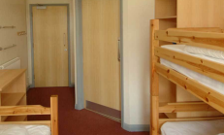
FRONTIER CENTRE
🚘 45 mins
📍Addington Road Irthlingborough NN9 5UH
📞 01933 654120
📩 frontier@rockuk.org
🌐rockuk.org/centres/frontiercentre

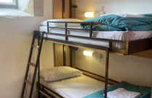
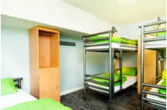
CHELLINGFORD CENTRE
🚘 45 mins
📍Felmersham Road Carlton, MK43 7NA
📞 01234 720726📩admin@chellington.org
🌐chellington.org/school-groups
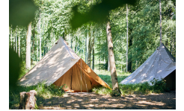
YHA STRATFORDUPON-AVON
🚘 60 mins
📍Stratford-upon-Avon Warwickshire, CV37 7RG
📞 0345 371 9661
📩stratford@yha.org.uk
🌐yha.org.uk/hostel/yha-stratfordupon-avon
CAMPING: THE BUSHCRAFT COMPANY
🚘 45 mins
📍Boughton Woods, Chase Lodge, NN14 1EB
📞 03332 000612
📩info@thebushcraftcompany.com
🌐thebushcraftcompany.com/ locations/boughton-woods

